Core Competency Challenge
“What did your job do for you today?”

When I first began working at Blueridge, Doug, David, and Paul viewed the Community Living theme dances as monthly torture. I will never forget the first time one happened to fall on my shift. From the minute I got there, the moaning and groaning commenced. “We don’t WANT to go to the dance tonight, Jessica.” “It’s too loud in there.” “I want to watch hockey.” I laughed off the comments at first, but when they didn’t stop I told them that even though they didn’t really like going to the dances, that Blair LOVED them. I said, “Since Blair often does things that he doesn’t really enjoy for you, like watching TV shows he’s not interested in, you guys can do this for him.” And with a promise of a visit to Tim Horton’s afterward, we were off.

Upon arrival, Blair was off like a shot doing laps of the dance floor. Paul, Doug, and David on the other hand, promptly found three chairs lining the edge of the dance floor and parked themselves in them. I enthusiastically tried getting each one up to dance, and was met with negative responses and a couple “leave me alone” type hand-waves. “Fine,” I thought to myself, “If they won’t give it a shot, I’ll show them how much fun they’re missing out on.” Then I went off to find Blair, and on the way found clients from a few other homes I work at. I was dancing with all of them and having fun, when I felt someone push my shoulder. There was Paul, a huge grin on his face, primed and ready to show me how the YMCA was done! When I caught Doug and David watching I waved them over, and Doug got up and joined in too! Another song later and David still wouldn’t get up, so the three of us went over and encouraged him to join in on the fun. Finally he caved, and came out onto the dance floor. It wasn’t long before he was dancing away too! I was happy they were having such a good time, and a few songs later it was time to head home. They chatted the whole way about how much fun they had, and how they couldn’t wait until the next one.

After showing Gayle some photos of the fun, she was surprised and told me that I was the first staff member to ever get all four of the guys up on the dance floor. It was probably the proudest moment of my career so far, knowing that I was able to make a difference in the lives of the people I support. Now when I show up on dance night, instead of moans and groans I am greeted with enthusiasm and chatter about how much fun it’s going to be! They’ve become the highlight of the month, for all the guys at Blueridge and for myself.

Here are some photos from the most recent St. Paddy’s dance!

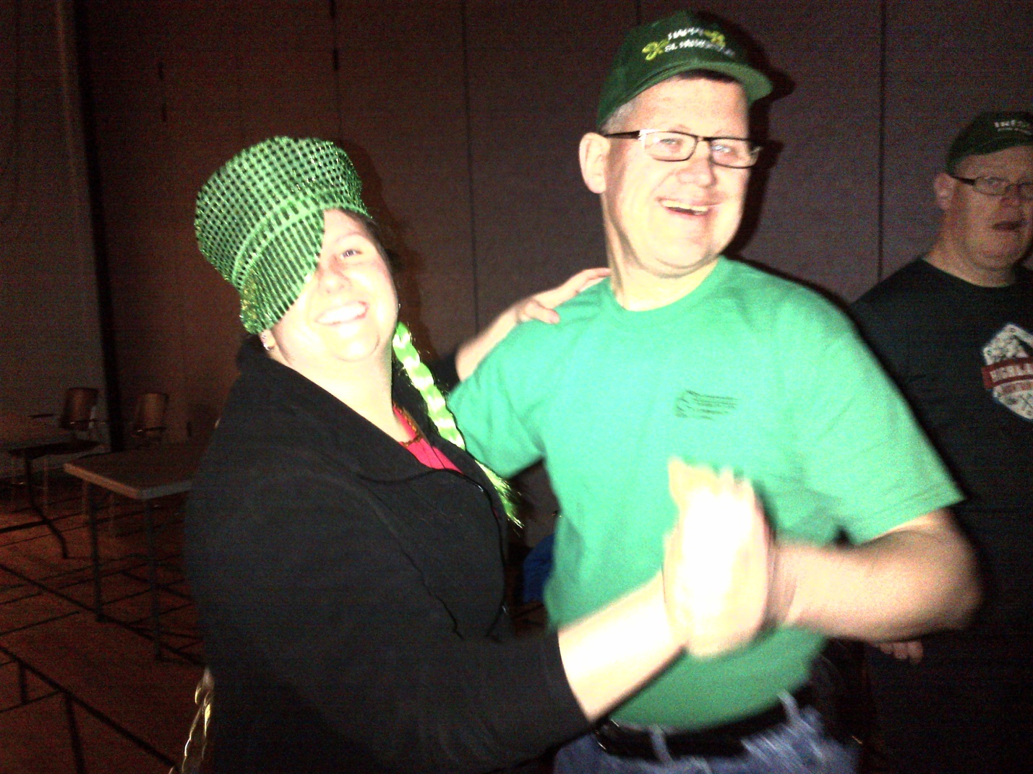
“You want a girlfriend, right? Ladies like a man who can DANCE!”

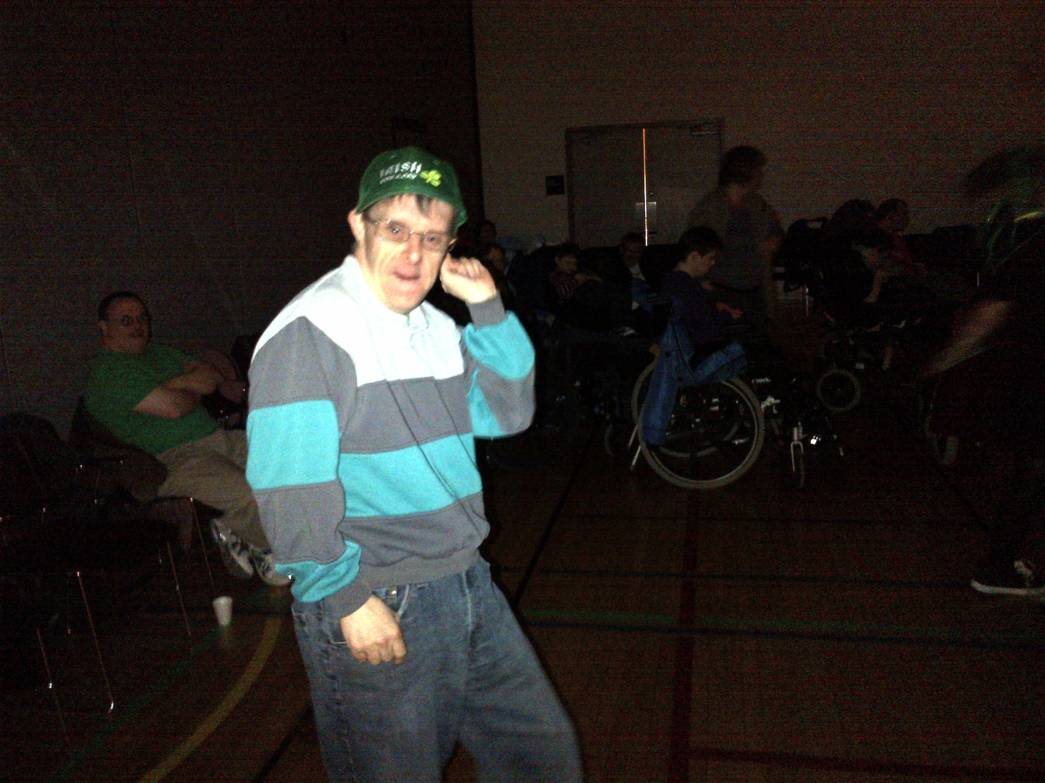
Paul, showing me how it’s done.

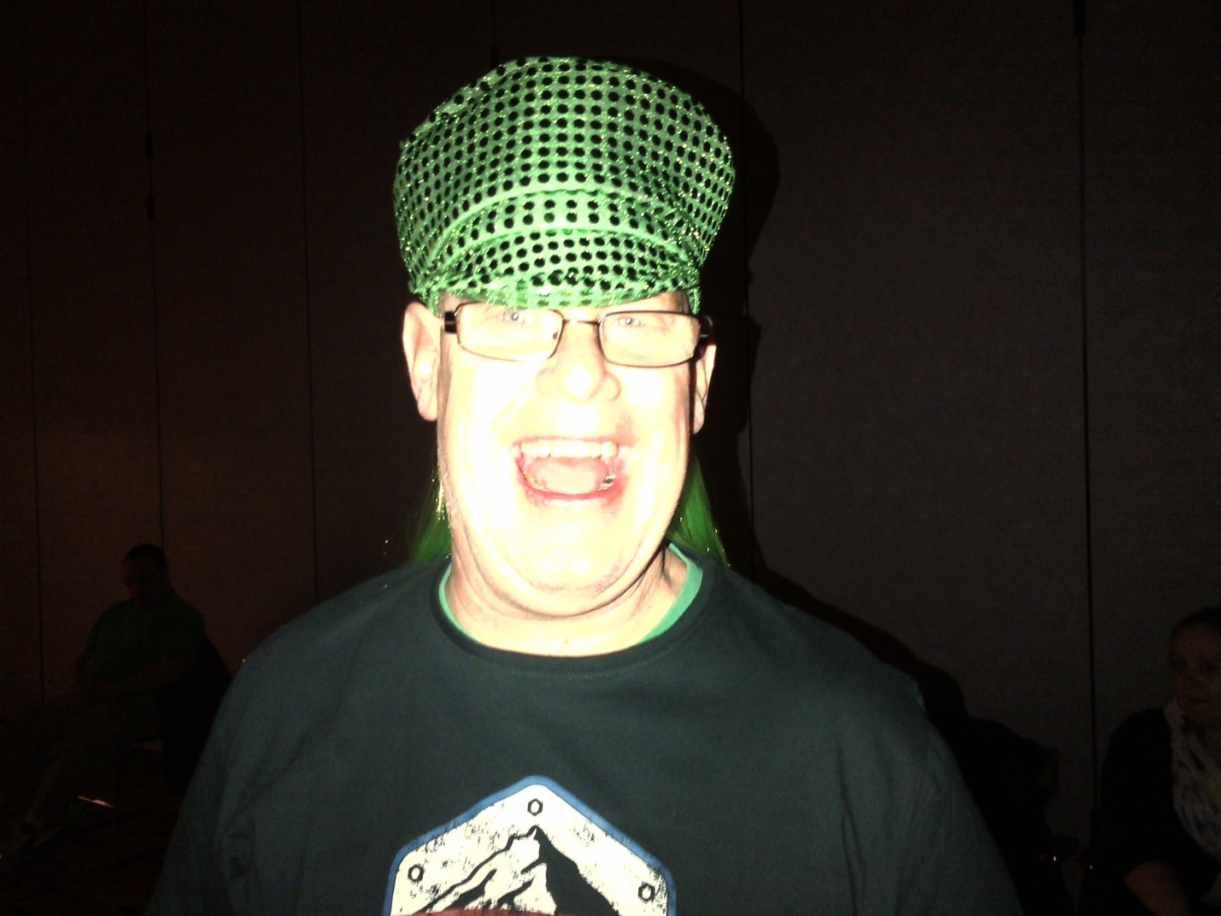
Doug, modeling the most spectacular hat!
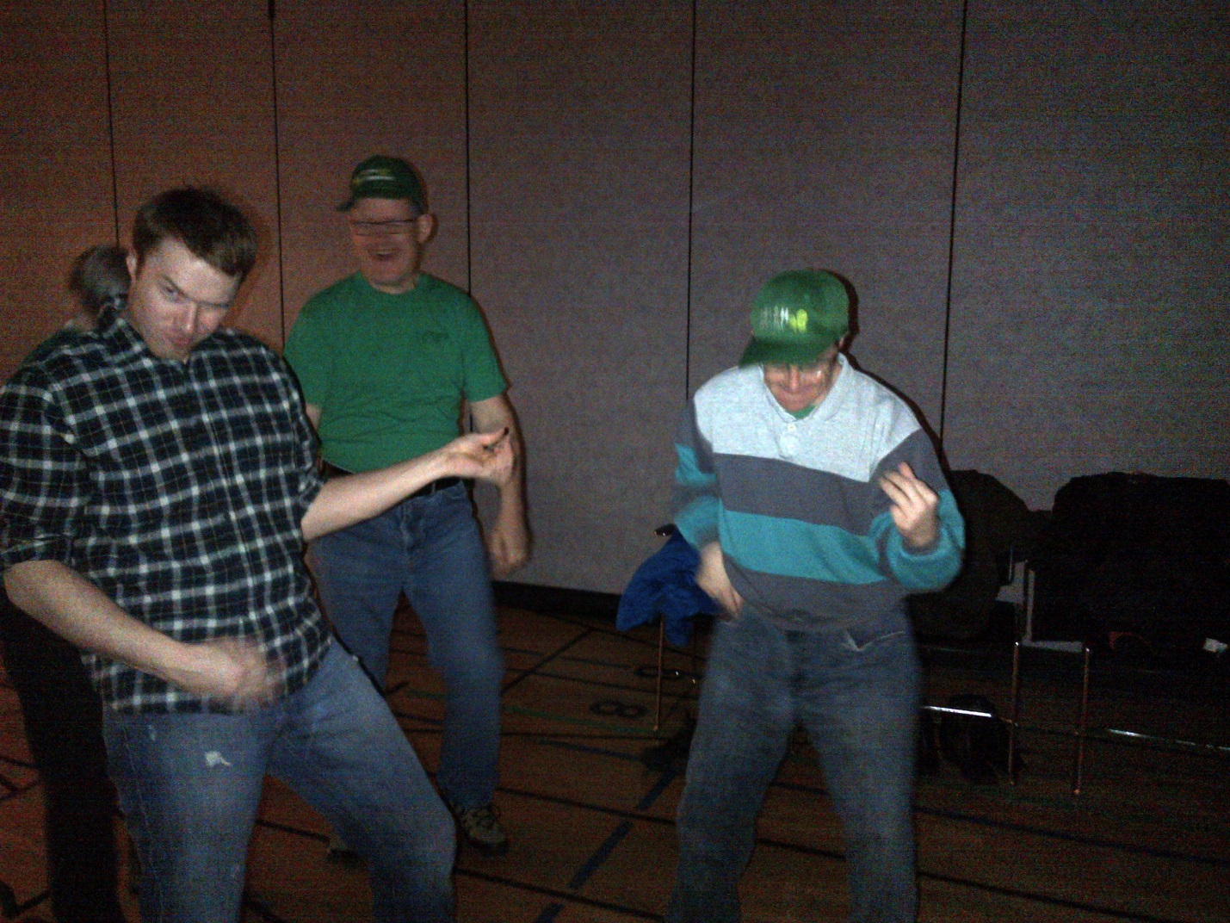
A dance isn’t a dance without some rockin’ air guitar.
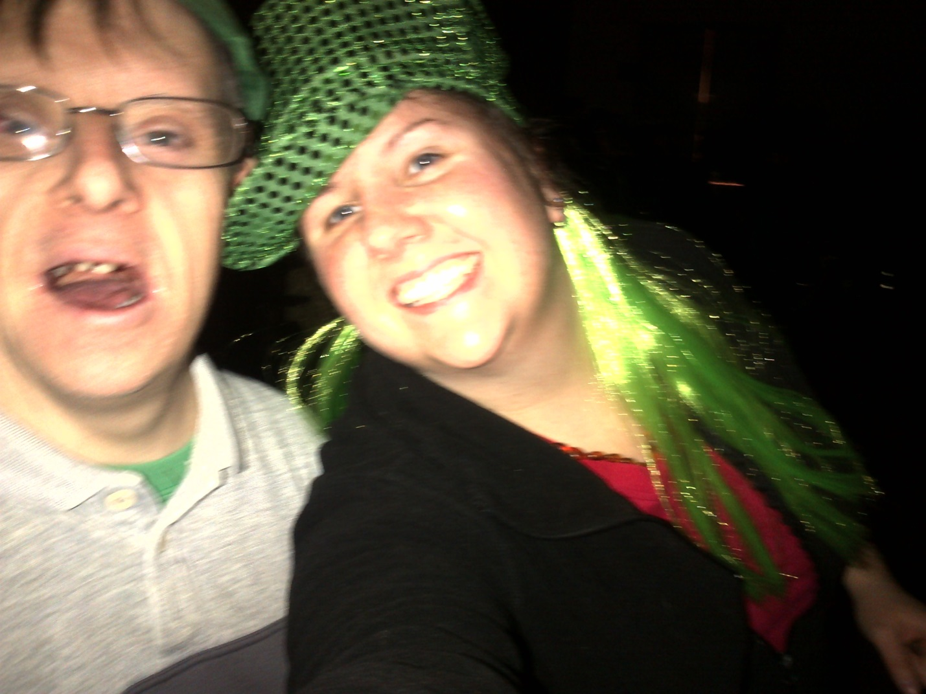
Paul and I, having a great time!

